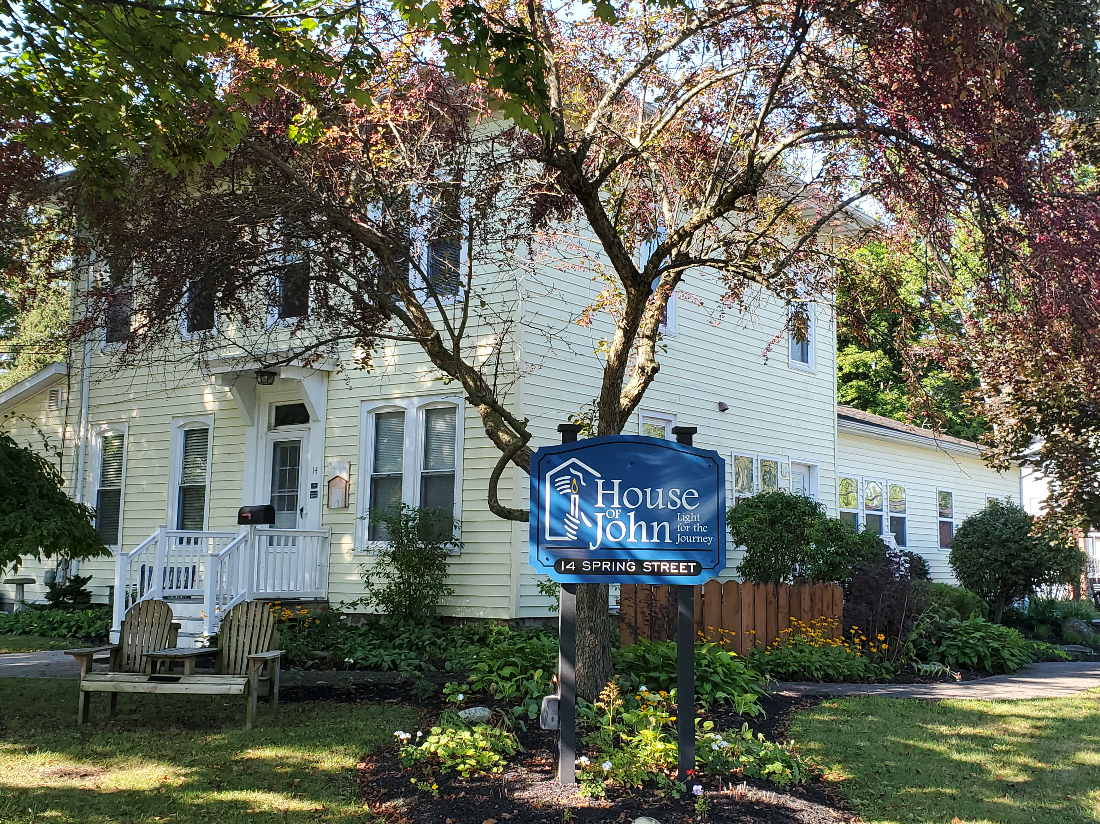

ANNUAL REPORT

2022
House of John
Email: house@houseofjohn.org  Website: houseofjohn.org | Tel: (315) 462-5646  14 Spring Street  Clifton Springs, NY 14432 | 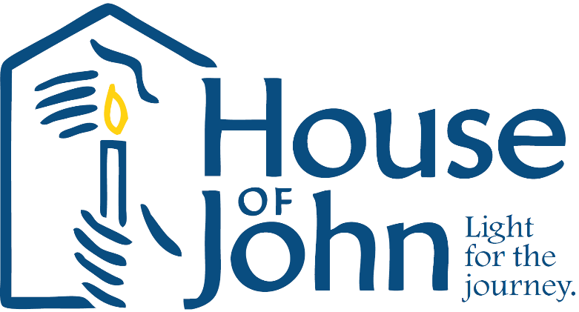

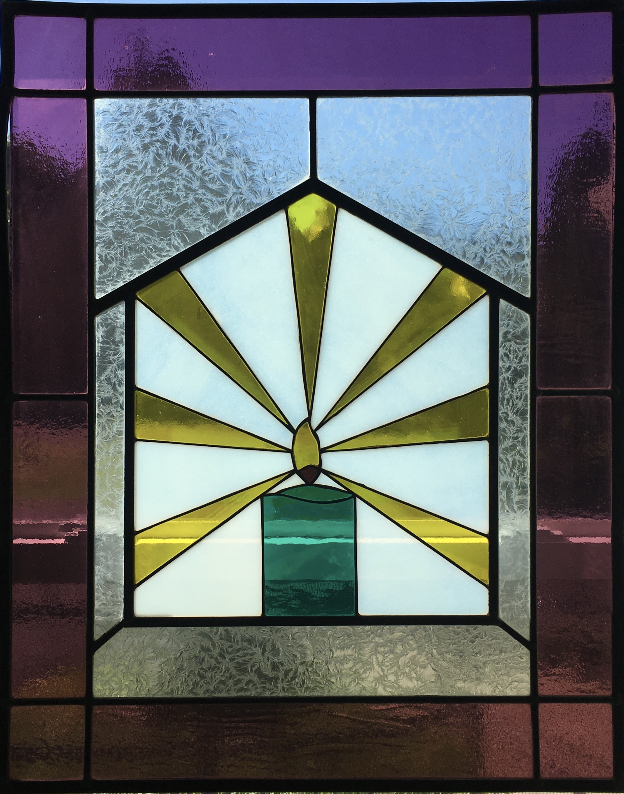
Our Mission
We open our house, our hearts and our hands to those who need physical care, emotional support and spiritual sustenance as they approach the end of their lives. We feel blessed to share the journey and we are privileged to be present with the family and loved ones during bereavement.
All services at House of John are free of charge. We depend completely on donations to keep the House in operation.
Comments from residents families
From a grateful family member: “Everyone’s life journey should be able to be in a setting like yours at its end. I can’t thank you, your team and all the volunteers enough. The kindness and compassion you showed my mom, and all our family was incredible.”
From a daughter who works in healthcare:
“I mentioned to you that I had an interest in going into palliative care professionally, and this experience has only solidified that. You have all shown me the utter importance of caretaking at such a pivotal time in a patient’s and family’s life.”

Resident Information
The House of John assisted 16 residents, and their families, over 182 resident days during 2022. This is 5 less residents and 9 fewer days than the previous year. We continue to care for one resident at a time due to the decreased number of active volunteers able to share their time with us.
178 referrals were received in 2022 from area hospitals, nursing homes, family members and UR Medicine Hospice which is decreased from 193 referrals in 2021. All referrals are reviewed, and contact made with potential residents and/or family members, by the HOJ Executive Director. The Director and Care Coordinator also visit potential residents face-to-face to discuss the House of John philosophy of care, answer questions, and to review the admission process and visitation policy. This introduction gives residents the opportunity to begin to build a rapport with the HOJ staff which can serve to ease anxiety on admission day.
Residents are chosen based on those with the most immediate need who have the fewest available resources for care.
The average length of stay in 2022 was 11 days with the shortest length of stay less than 24 hours and the longest was 38 days.
The average resident age was 78 years old. The age range of our residents during 2022 was 53 to 96 years of age.
The predominate medical diagnosis (69%) of our residents was some type of cancer. Other admitting diagnoses were dementia, chronic/end stage kidney disease, congestive heart failure and end stage lung disease.
A majority of the residents (56%) resided in Ontario County before coming to the House of John. We also cared for residents from Monroe, Yates, and Wayne Counties.
Our Staff and Volunteers
Resident care at House of John is provided by paid staff and a dedicated group of compassionate, giving, trained volunteers.
Paid staff remained consistent during 2022 with one per diem overnight aide being hired to help cover vacation and sick time of the regular nighttime staff. One on-call nurse was added, with a goal of adding an additional on-call nurse to the rotating pool.
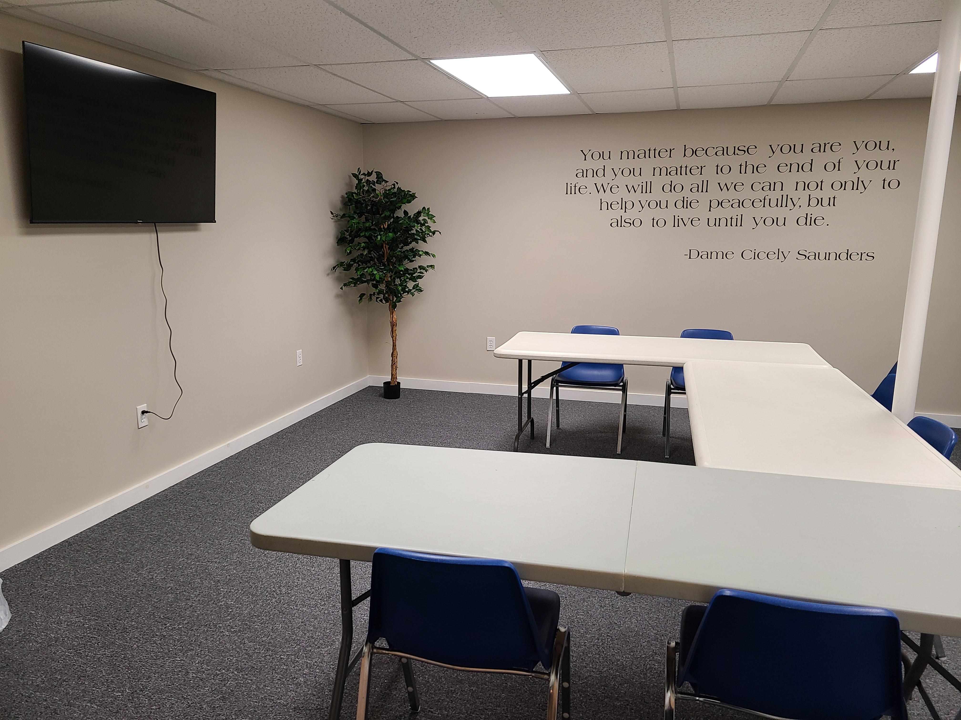
The training room in the basement got some finishing touches, funded by grant monies, in 2022 including a fresh coat of paint, carpeting, a new laptop computer and wall-mounted monitor, and a hospice inspired wall decal.
Three new volunteer training classes were held over the course of the year for 11 new volunteers. The annual volunteer update training classes, “Volunteer Connections”, were held over the summer as a refresher for experienced volunteers.
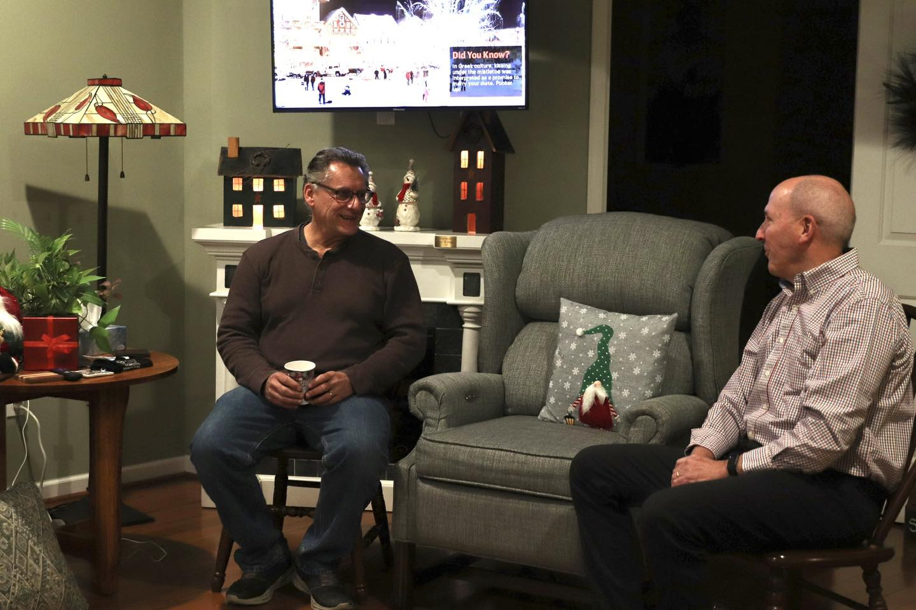
Volunteers provided a total of 2,160 hours last year, enabling the House to remain open and continue providing care to those at end-of-life.

House of John hosted the first Volunteer Recognition
Dinner in three years on June 1st at Warfield’s Restaurant.
The Holiday Open House celebration also returned in
December and was held at HOJ. These celebrations
were wonderful opportunities for volunteers to reconnect!

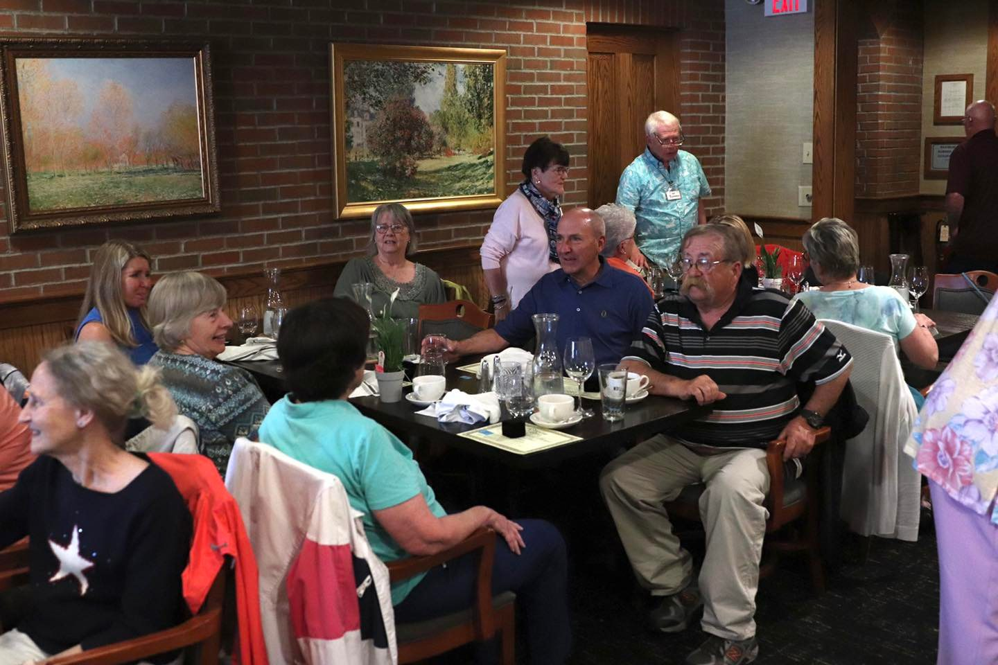
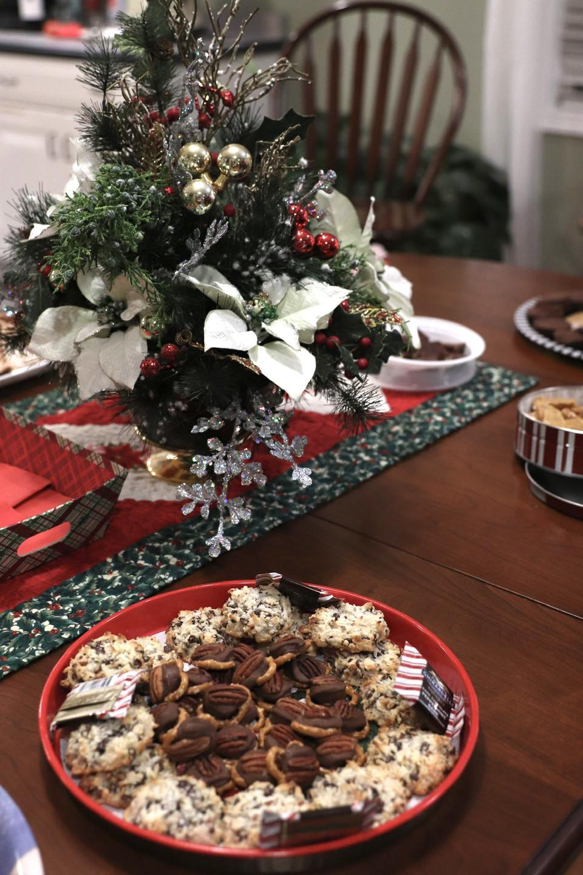

Recruiting new volunteers remains a top priority for 2023!

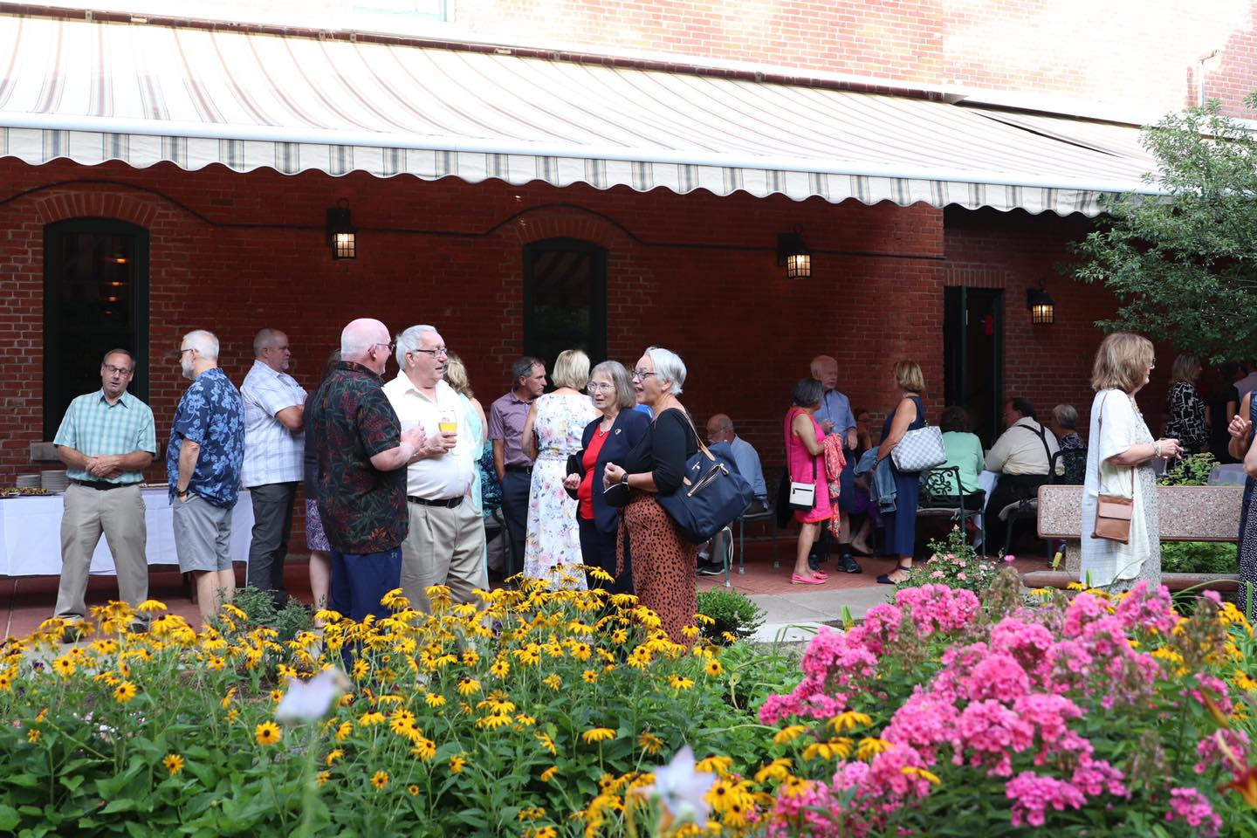
Fundraising Events
The annual Winemaker’s Dinner was held on July 30th at Warfield’s Restaurant. The Executive Chef at
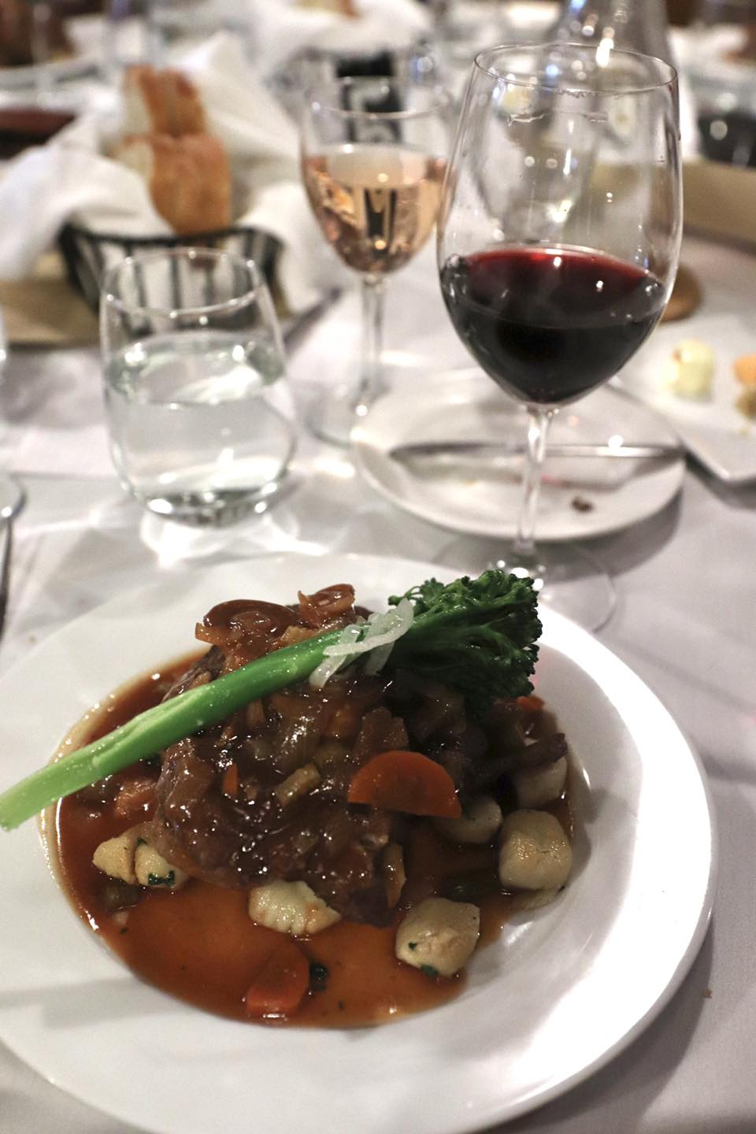
Warfield's and a local sommelier took guests through a guided food and wine pairing dinner. The dinner was a wonderful success, from the beautiful weather to the delectable food and wine. Attendance increased slightly from 2021, which is significant in that the event ticket price increased from previous years.

Thank you to all at Warfield’s Restaurant for the
continued support to House of John!

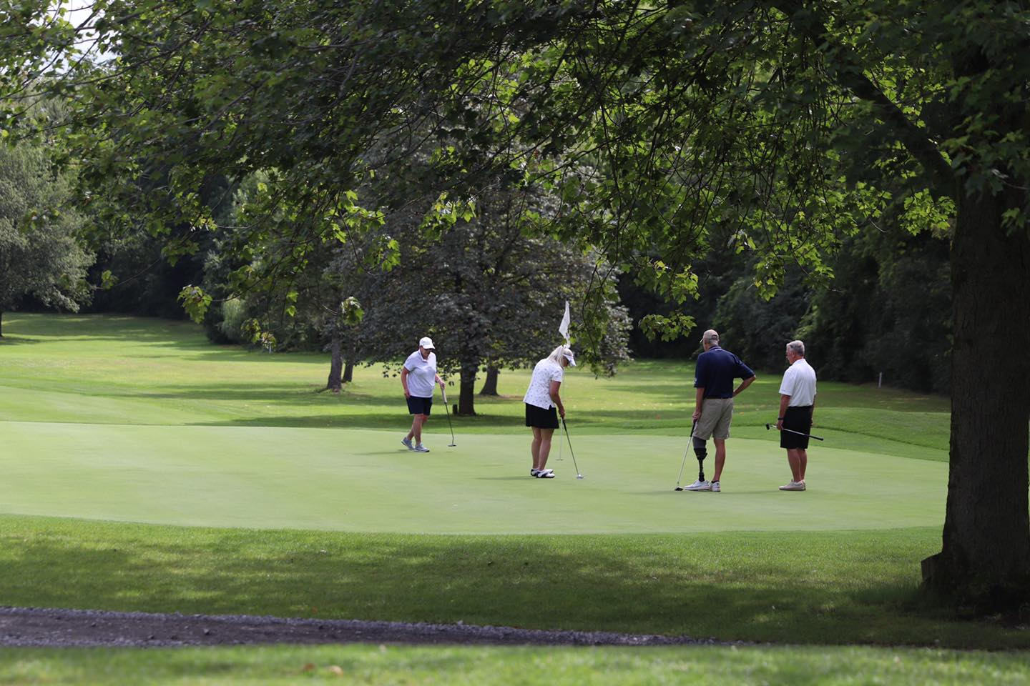

Despite the rain, the annual golf tournament at the
the Clifton Springs Country Club proved to be
another very successful fundraiser with net
proceeds totaling more than $35,000!

In November, the House of John team reflected on how very grateful we are for the caring community we call home. The continued support from our donors is unmistakable. The 2022 Annual Appeal raised more than $85,000, exceeding the campaign goal by 35%!

It is with the generous support of our volunteers, donors, and the local community that House of John can continue to provide dignity, care and compassion at end-of-life with no cost to residents or families and we Thank You!

House Updates
Older homes need repairs and updating from time to time and House of John is no different. The whole house generator was found to need extensive repair during the annual inspection and was ultimately replaced. The furnace in the addition and the dishwasher were also replaced in 2022.

The director’s office, which is also used for meetings and to counsel families, was painted using grant monies. Both the director and care coordinator offices now have beautiful new light filtering window shades as a result of a generous donation specifically for the project.

Community Outreach
We’ve seen first-hand the kind of positive impact that neighbors taking care of neighbors can have in a community. Throughout the year, the House receives donations of household items, personal care items, medical supplies and equipment (dressing supplies, walkers, crutches, shower chairs, commodes) and food, as well as landscaping, construction and “handy man” services in addition to monetary gifts. The medical equipment donated by residents, families and the local community are made available to others through our “loan closet” and is a wonderful example of how those in the Phelps-Clifton Springs and nearby communities take care of each other.
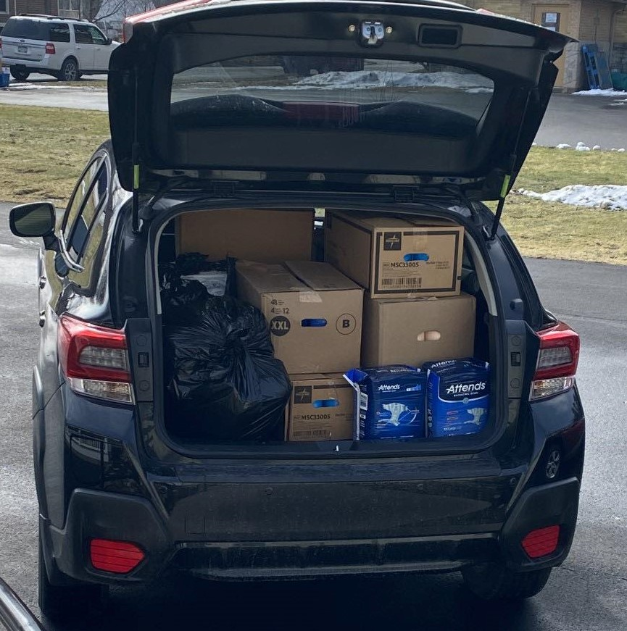
Our reach crossed oceans in March 2022 when HOJ donated
two carloads of surplus personal care items for those in need in
the Ukraine at a relief drive sponsored
by Clifton Springs Hospital/Rochester
Regional Health.

In an effort to improve community knowledge of House of John and share its mission, the director and care coordinator offered several informational presentations during 2022. These interactions included an interview with the Finger Lakes Radio Group, in-person presentations at Clifton Springs Hospital to a nursing student group and at Seneca Family Health Center to a group of primary care providers and remote meetings with four groups of St. John Fisher University nursing students. Prior to the Covid-19 pandemic, SJFU nursing students volunteered at House of John as part of the Palliative Care/End-of-Life care course they are required to take. In-person clinical hours for the SJFU nursing students will resume in Spring 2023.

Challenges Moving Forward
Recruitment of new volunteers
The volunteer pool increased during 2022 and the effort to continue this trend remains a primary goal. The first volunteer training class of the new year is scheduled to begin in early March. Various efforts to recruit new volunteers will continue throughout the year, including speaking to various local church groups.

The use social media to connect and engage with others helps. Staff, volunteers, and members of the board of directors are encouraged to use social media to reach out to their contacts as well as to share the mission of the HOJ to family, friends, and co-workers.
Feel free to “Like” the HOJ Facebook page: https://www.facebook.com/people/House-of-John/100064542258136/

30th Anniversary
In September of 2023 the House of John will be celebrating our 30th Anniversary!
The House opened for its first resident in September of 1993. Over the past 30 years, the dedicated staff and volunteers have touched the lives of over 780 residents and countless families and friends.

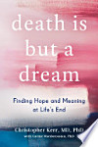
Plans are in the making for celebrating this milestone and will include a community event featuring Dr. Christopher Kerr, a Hospice/Palliative Care physician and CEO and Chief Medical Officer at Hospice Buffalo. Dr. Kerr has done extensive research with hospice patients and their families regarding the dreams and visions often reported by the dying. He is the author of the book Death Is But a Dream, where he highlights his research and how these visions bring comfort and meaning to the dying process.

Details of 30th Anniversary events will be shared later in the year.
families in Buffalo, NY, highlights and validates the powerful dreams and visions often experienced at end of life that bring comfort and meaning to the dying process.

Please Share:
Volunteers Needed
If you find yourself with a few extra hours of time each month and are interested in giving back to your community, please consider joining the House of John family. Staff and volunteers provide physical care and emotional support to residents and their families at end-of-life. Volunteering here at the House can be a rich experience, one that binds our House of John family together, enriches the greater community and makes a difference every day in the lives of our residents and their loved ones.
Training and orientation are provided for all volunteer caregivers and is offered at no cost. Initially, prospective volunteers shadow with a seasoned volunteer to become acquainted with the House. Following volunteer training, new volunteers are always paired with an experienced caregiver.

We invite you to check our website, HouseofJohn.org, for pictures of the inside of our wonderful home and to view a short video which can be found on the “About Us” page below “Our Story”. https://www.houseofjohn.org/about.html

